CICD Short Notes

**what is Devops?**



* DevOps is a software development approach which involves continuous integration, continuous testing, Continuous delivery, Continuous deployment, and continuous monitoring of the software throughout its development lifecycle.
* This is the process adopted by all the top companies to develop high-quality software and shorter development lifecycles, resulting in greater customer satisfaction, something that every company wants.

**Various DevOps lifecycle stages.**



* **Plan.** This phase helps define business value and requirements. Sample tools include Jira or Git to help track known issues and perform project management.
* **Code.** This phase involves software design and the creation of software code. Sample tools include GitHub, GitLab, Bitbucket, or Stash.
* **Build.** In this phase, you manage software builds and versions, and use automated tools to help compile and package code for future release to production. You use source code repositories or package repositories that also “package” infrastructure needed for product release. Sample tools include Docker, Ansible, Puppet, Chef, Gradle, Maven, or JFrog Artifactory.
* **Test.** This phase involves continuous testing (manual or automated) to ensure optimal code quality. Sample tools include JUnit, Codeception, Selenium, Vagrant, TestNG, or Blaze Meter.
* **Deploy.** This phase can include tools that help manage, coordinate, schedule, and automate product releases into production. Sample tools include Puppet, Chef, Ansible, Jenkins, Kubernetes, OpenShift, OpenStack, Docker, or Jira.
* **Operate.** This phase manages software during production. Sample tools include Ansible, Puppet, PowerShell, Chef, Salt, or Otter.
* **Monitor.** This phase involves identifying and collecting information about issues from a specific software release in production. Sample tools include New Relic, Datadog, Grafana, Wireshark, Splunk, Nagios, or Slack.

**CI/CD Workflow Pipeline**



**SCM and the CI/CD Pipeline**



**SCM**



Source Control Management (SCM) is an important component of CI/CD Pipeline.

• It is a huge part of the daily developer’s workflow:

• All Code changes made by developers will need to be tracked in SCM

• Developers will use SCM to track their changes separately and then merge them together

• All pieces of automation that need to interact with the source code will use SCM:

• Continuous Integration (CI) will get the code from SCM

• SCM will notify the CI server when code needs to be built

**How CI Works**





Build Pipeline / CI Pipeline











**Build Phase / Build Automation**







**Testing Phase / Automated Testing**





**Testing types**

1. Unit Testing

2. Integration Testing



* **Unit Testing:** It is the testing of an individual unit or group of related units. It is often done by the programmer to test that the unit he/she has implemented is producing expected output against given input.
* **Integration Testing:** It is a type of testing in which a group of components are combined to produce the output. Also, the interaction between software and hardware is tested if software and hardware components have any relation. It may fall under both white box testing and black box testing.

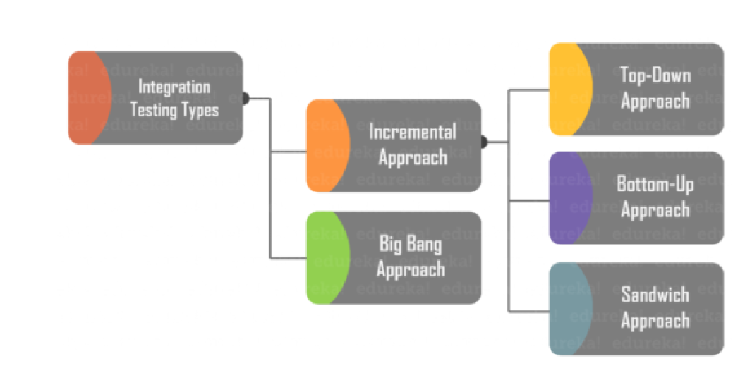



**What is CD?**







**Release pipeline /CD Pipeline**

















**Deploy Phase**





**Auto Test Phase:**

Once the code is deployed successfully, you can run another series of Acceptance Tests or Sanity test for the final check. If everything is accepted, then it can be deployed to production.





**When to perform UAT Testing?**

At the last stage before the software goes live or made available for users

UAT performs after Unit, integration, System testing.

UAT testing is performed when all the measure bugs are fixed

UAT Testing is performed when fully integrated and bug fixed software is available.

**Sanity Test:**



**Deploy to Production:**



**Measure & Validate:**

The pipeline continues until we get a product or application which can be deployed in the production server where we measure and validate the code. Splunk, ELK Stack, Nagios etc. are some of the popular tools for monitoring.



This lifecycle continues until we get code/a product which can be deployed to the production server where we measure and validate the code.













